Amazon Tracking Number Checking Guide

- Import/Insert Amazon Records:
  - http://34.196.137.61/barcode/amazon_trackingnumber_checking.php
  - Select Dates Use page default import date (Last Month Day 1 to Date):
  - Click Insert Orders

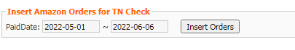

- Generate Report:
  - http://34.196.137.61/barcode/amazon_trackingnumber_checking.php
  - Select Dates (Last Month Day 1 to Date):
  - Click Show Orders TN

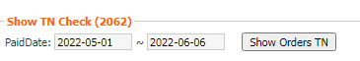

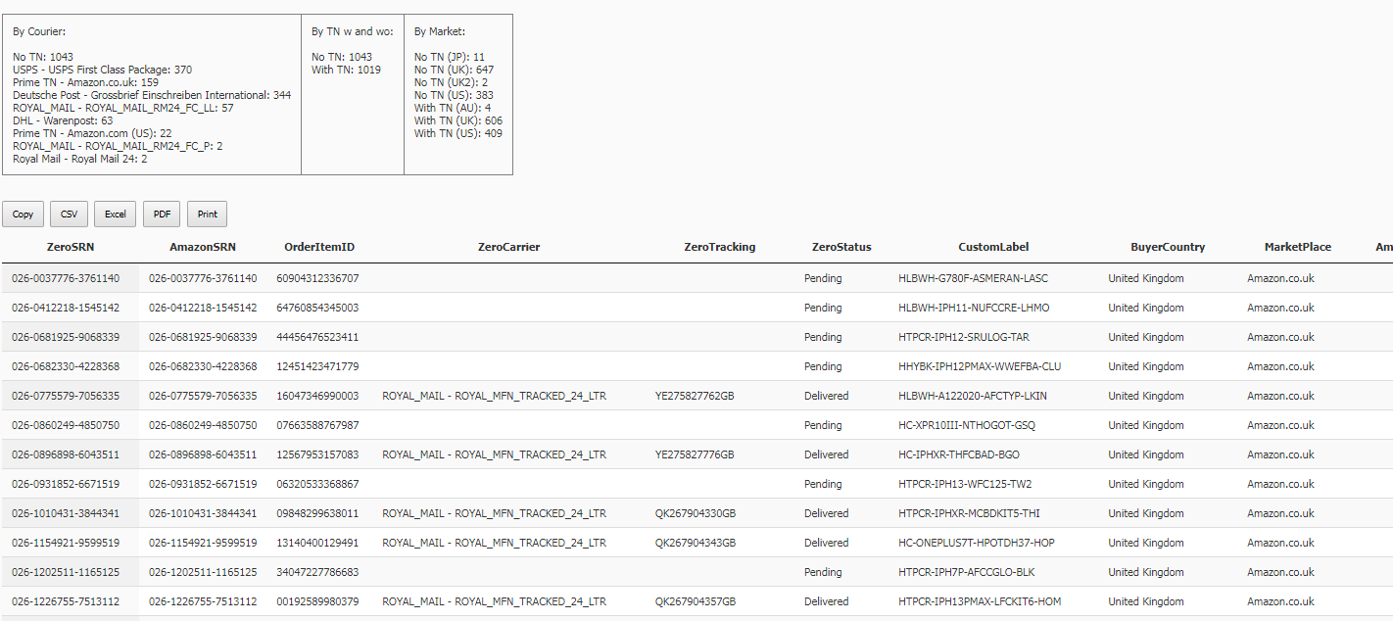
- Verify Page Output:

- Run the Amazon TN Checking Tool (AmazonOrderGetTrackingInfo_ConApp_Selenium)

- Once the tool is done running, refresh the page: http://34.196.137.61/barcode/amazon_trackingnumber_checking.php

All linked TN in Amazon are removed from the page, if there are still remaining records, relink TN on the page: http://34.196.137.61/barcode/AmazonDispatchRecords.php

Or manually link them on Amazon, then return the Amazon TN Checking Tool (AmazonOrderGetTrackingInfo_ConApp_Selenium)

Until all TNs are confirmed linked in Amazon.

Notes in running the tool:

- Script: EcellMarketPlaceTools\DatabaseConnection\SQL_SELECT.cs

- Default Run(Check with Zero TN only):
  - Check all the records with available TN on Zero
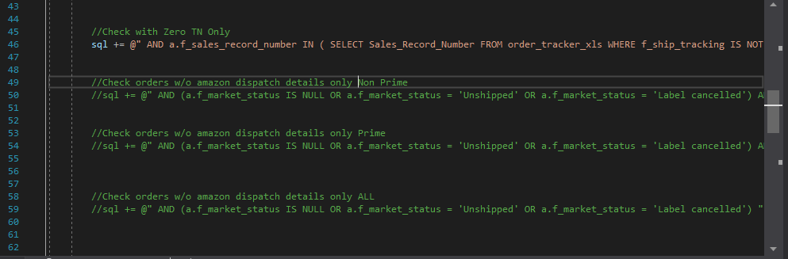

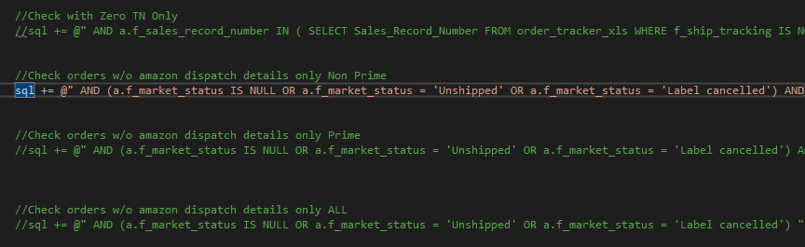
- Check all Prime orders with Delivered Status, but no TN in Zero

- Check all non prime orders w/o Amazon Dispatch details – verify orders for late shipments

